Balaclava State School Attendance spotlight

Attendance success
Balaclava State School, in central Cairns, has a Prep to Year 6 enrolment of almost 330 students, which reflects the multicultural face of the area. The school sets high expectations around student attendance, aiming for attendance rates to ‘drive into the 90s and beyond!’

Attendance data in Semester 1, 2015 was 89.1% - an increase of 2.5% from 2014.

Balaclava State School Principal, Ms Jane Termaat, strongly believes that one of the greatest strengths the school has to support and improve attendance is ‘having the right people in the right job’.

Karen Roome, Head of Student Services, is fondly known as the ‘heart of the school’. She passionately looks after student enrolment, attendance and transition. Not only does she wear this commitment to students proudly but when attendance hits the ‘green’ (over 90%) – she even makes sure her clothing matches!
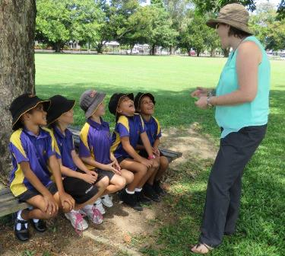
Attendance is over 90% - Ms Roome is wearing green.

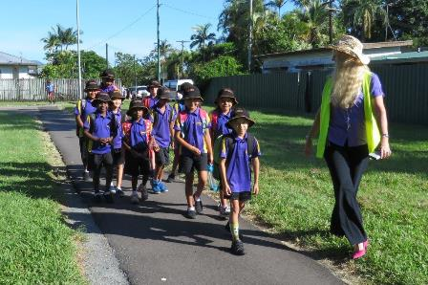

Ms Termaat welcoming the walking bus.

Key strategies employed by Balaclava State School include:

Welcoming students and their families
- knowing the names of each and every student at the school
- building positive relationships with families and strong school-community partnerships
- holding a ‘gold coin’ community breakfast for the whole family at the start of each term to welcome the students back from the holidays
- running a ‘walking bus’ twice a week which meets the kids in parks and significant locations and makes getting to school an exciting event
- running weekly breakfast and lunch programs.

Collecting, analysing and responding to data
- tracking of attendance – on a daily and weekly basis
- tracking students who are persistent non-attenders
- arranging home visits for students who have not attended for 3 or more days.



Staff analysing the attendance data.

Communicating with parents and students
- publishing data on the bulletin board
- acknowledging strong attendance on parade and in school newsletters
- celebrating classes with over 90% attendance with Facebook posts

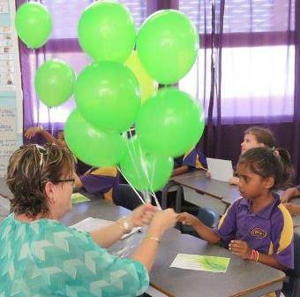
Celebrations for 2A- the first class of 2016 to reach 100% weekly attendance.

Ms Termaat is clear – Our philosophy is…

‘We care about you, your child, and your child’s learning.

What can we do to help and support you to get your child to school every day?’

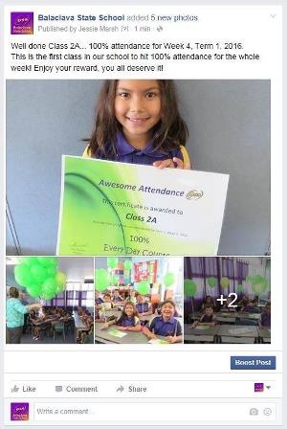

Facebook post for 100% attendance

- having persistent and consistent messages about being at school every day and that missing out on school means you are missing out on learning
- having the adopt-a-cop to reinforce the messages where possible
- using formal legal processes only as a very last resort.

