Deception Bay State High School

Attendance Spotlight

Our School
Deception Bay State High School is located at the southern end of the Sunshine Coast. It services Deception Bay, Rothwell and Mango Hill with a small number of students travelling from the Redcliffe Peninsula, Burpengary and Kallangur areas. The school, which opened in 1992 with 200 Year 8 students, offers co-educational schooling for Years 7 to 12, mature age students and two Flexible Learning Programs.
Our four school values of ‘Belonging, Integrity, Aspiration and Persistence’ underpin our vision for a strong and vibrant learning culture.

Improving attendance
In response to attendance rates slipping in 2014, we developed an Attendance Improvement Plan to address this important issue.
Following the implementation of our plan, attendance rates are steadily increasing.

Year | Attendance Rate
2014 | 83.4%
2015 | 86.4%
2016 | 89%

Key strategies employed by the school include:
Developing a positive school culture
- Aligning attendance within our school’s comprehensive Schoolwide Positive Behaviour Tier I system by providing clear expectations and offering student rewards.



Celebrating high attendance achievers

Celebrating and acknowledging high attendance through Student of the Month awards and whole class attendance

awards
- Using the VIVO Miles online rewards system for secondary schools to reward students using electronic points which they can redeem from a catalogue.
- Communicating frequent attendance messages through school and year level parades, school newsletters, the school’s website, and at parent teacher interviews.
- Following exploration of a Woodridge SHS initiative of ‘influencing beyond the school gate’, one key idea adopted by our school has been the implementation of home visits by a dedicated ‘A Team’. The A team is made up of a group of dedicated staff members responsible for attendance checks, support and intervention, including daily phone calls and home visits.
- Having students/parents sign an attendance agreement upon enrolment for new students and annually at parent teacher interviews.
- Gaining community support to help establish and clarify the expectations around attendance. Our A Team staff liaise with staff at local shopping centres and fast food outlets and encourage them to report truanting students to the school.
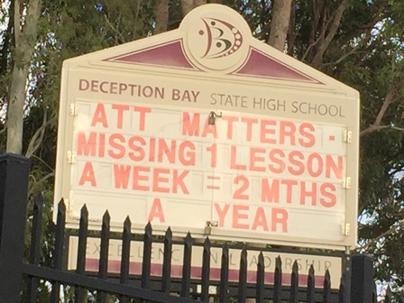

Using the message board for attendance reminders

Addressing student attendance
- Monitoring weekly attendance and distributing a weekly email to all teachers publicising school weekly attendance and individual class attendance. We create a weekly poor attendance priority list for follow up by phone calls and/or home visits by the A Team.
- Identifying and supporting students with low attendance.
- Scheduling fun events on days that have traditionally poor attendance.
- Arranging for staff to visit ‘hot-spot drops’. A Team staff complete a daily patrol of known truancy locations and either direct students to return to school or report student truancy to Administration.
- Meeting with parents at school to address attendance concerns.
- Home visits to meet with families to identify issues and offer support if required.

Providing intervention and support
- Ensuring students are supported, valued and feel a sense of belonging is the core business of staff at DBSHS.
- Providing ongoing mentoring and support to improve the engagement and attendance of students with identified low attendance.
- Engaging a school case manager for at-risk students.
- Supporting students and families by referring them to relevant support agencies if required.
- Establishing a mentoring program linking disengaged students to support staff.
- Ensuring parents are aware of their legal obligation regarding attendance through the attendance contract and through conversations with the parents of chronically absent students.
- Offering support for parents to get their children to school, arranging for A Team staff to do home visits to support parents having difficulty getting students to school, and driving students to school if required.



Monthly attendance awards

Every day does indeed count towards a quality education at Deception Bay State High School.

Every day does indeed count towards a quality education at
Deception Bay State High School.

