
COMPRESSED GAS CYLINDERS

DO NOT use a gas cylinder unless you have been instructed
on its safe use and operation.

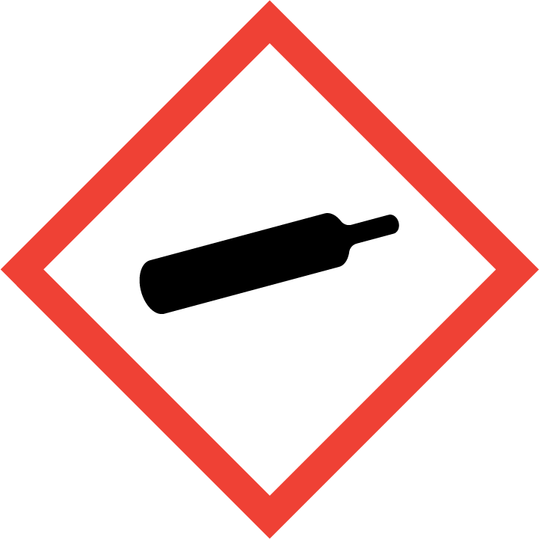
CYLINDERS MUST
BE STORED UPRIGHT AND SECURED

PRE-OPERATIONAL SAFETY CHECKS
- Always check the identity of the gas in the cylinder before use. Refer to the cylinder label and safety data sheet if required.
- Check that the pressure regulator is not defective. Replace immediately if faulty.
- Check the hose/fittings for signs of deterioration (splits, cracks, fraying). Replace immediately if damaged.
- Ensure that the cylinder is kept upright and secure during storage, handling, transport and installation.
- Cylinder valves must always be closed and all equipment detached when the cylinder is moved.
- Regularly check for leaks using soapy water. Leakage will be revealed by either hissing or, in the case of fuel gases, by an odour. DO NOT TEST FOR LEAKS WITH A NAKED FLAME.

OPERATIONAL SAFETY CHECKS
- Cylinders MUST always be secured.
- Never open the cylinder valve unless the cylinder is connected to a regulator or to equipment.
- Never use force when opening or closing valves. Only use reasonable force. OPEN by turning the hand wheel or cylinder valve key anticlockwise. CLOSE by turning the hand wheel or cylinder valve key clockwise.
- Keep all cylinders away from heat and ignition sources.
- When in use, cylinder valves used in the fully open position may become stuck in this open position. To prevent this ensure that the hand wheel or cylinder valve key is turned back half a turn.

SAFE STORAGE OF CYLINDERS
- Deliver cylinders to the designated cylinder cage or loading bay.
- Full or empty compressed gas cylinders should be stored in a well ventilated area, preferably in the open, with some weather protection. Full and empty cylinders should be kept separate if space allows.
- Keep cylinders away from artificial heat sources (e.g. intense sunlight, flames or heaters), combustible materials or flammable liquids.
- Keep cylinders in well drained areas, out of water pools or ponds. Do not store in confined spaces.
- The storage area should be secure, kept well ventilated and clean at all times. The ground surface should be reasonably level and firm (preferably concrete), that allows for easy trolley access.
- Different types of gas must be stored separately in accordance with regulation (refer AS4332)
- The entry to stores must clearly show signage in accordance with WHS regulations. This includes placarding and labelling.

HANDLING CYLINDERS
  - Use a trolley to transport cylinders. Never allow cylinders to be laid down, fall down or rolled along the ground.
  - Cylinders must always be secured to a trolley when being transported and to the wall or bench when being used.
  - Familiarise yourself with, and observe, appropriate safe lifting techniques/postures prior to manually handling heavy or large gas cylinders. Assess the load weight and dimensions before attempting any lift.
  - Use suitable personal protective equipment (PPE) – wear safety footwear and leather gloves to protect against falling/ slipping cylinders crushing hands or feet during moving.

Transport of Gas cylinders
- Arrange for delivery of cylinders wherever possible.
- For transport in private vehicles for work purposes:
- Transport cylinders in an open vehicle.
- Ensure the service valve is turned off.
- Ensure the safety relief valve is positioned so that any gas release will not impinge on another cylinder.
- Ensure the cylinder has a current test date (no more than 10 years).
- Ensure there is a plastic screw plug in the cylinder outlet when not in use to prevent foreign objects/insects entering the valve.
- Use only approved containers designed specifically for the transport of liquefied.
- Firmly secure the cylinders to the vehicle and protected from other objects striking against them during transport.
  - Remove the cylinders from the vehicle immediately upon arrival at the destination.

Installation of cylinders
- DO NOT damage the threaded portions by connecting an incorrect regulator or fitting.
- DO NOT over-tighten or use excessive force to connect equipment.

POTENTIAL HAZARDS

- High pressure
- Explosion or major fire
- Asphyxiation should a leak occur

- Extremely low temperature (severe frost burns)
- Exposure to toxic gases (toxic atmosphere)
- Large gas cylinders are heavy. Incorrect handling may cause an injury

HOUSEKEEPING
- Ensure hand wheel is in closed position. Remove regulator and cap valve before storage.
- Ensure there is a plastic screw plug in the cylinder outlet or a safety cap covering the valve assembly during storage to prevent foreign objects/insects entering the valve.
- Keep equipment clean. Store valves, regulator, hose and other fittings in a clean, dry location away from chemicals.
- Full and empty cylinders must be stored in the dedicated storage area.
- Cylinders must be secured appropriately.

This SOP should be used in conjunction with
Date of last review | ______________ | Signature ______________________

Reviewed July 2018 V5
Uncontrolled when printed.
Department of Education
Organisational Safety and Wellbeing

Reviewed July 2018 V5
Uncontrolled when printed.
Department of Education
Organisational Safety and Wellbeing

Department of Education
Organisational Safety and Wellbeing
Department of Education
Organisational Safety and Wellbeing

