Healthy eating means choosing a wide variety of food from the five core food groups every day (according to the Australian Guide to Healthy Eating). How much food children require varies between children and is influenced by their individual rates of growth, size and importantly, physical activity levels.

Number of serves from each core food group needed by most children of Prep age

Food group | Serves per day | What is a serve?
Vegetables and legumes/beans  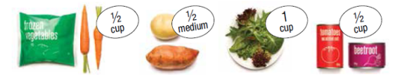 | 4¹/₂ | ½ cup cooked vegetables  1 cup salad vegetables  ½ medium potato  ½ cup cooked or dried legumes
Fruit  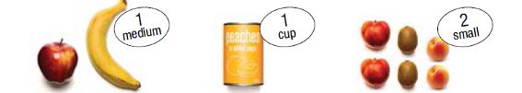 | 1¹/₂ | 1 medium sized piece (e.g. banana, apple)  2 small sized pieces (e.g. kiwi fruit, nectarines)  1 cup diced fresh fruit or canned fruit  Only occasionally include:  30 g dried fruit (e.g. 4 apricot halves)  ½ cup fruit juice
Grain (cereal) foods  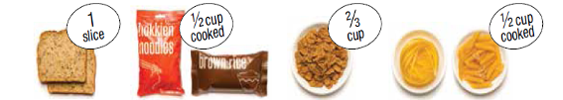 | 4 | 1 slice bread  ½ medium bread roll  ½ cup cooked rice, pasta or noodles  ⅔ cup wheat cereal flakes  ½ cup cooked porridge  3 crisp breads
Lean meats and poultry, fish, eggs, tofu, nuts and seeds and legumes/beans  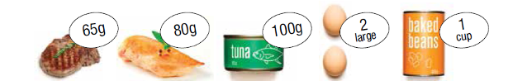 | 1¹/₂ | 65 g cooked lean meat like beef or pork  80 g cooked lean chicken or turkey  100 g cooked fish or 1 small can of fish  2 large eggs  1 cup cooked legumes/beans  170 g tofu  30 g nuts, seeds, or nut or seed paste
Milk yoghurt, cheese and/or alternatives, mostly reduced fat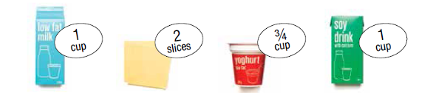 | 1¹/₂ – 2  Discretionary choices: only sometimes and in small amounts  These foods don’t provide many nutrients and are high in fat, sugar and/or salt. Up to ½ serve could be included occasionally for Prep children. (½ serve = approximately 1 sweet biscuit). | 1 cup milk  1 cup calcium fortified soy or rice milk  ¾ cup yoghurt  2 slices hard cheese  ½ cup ricotta cheese
Other food: unsaturated spreads and oils
A small amount of unsaturated fat is needed and this can come from spreads and oils, or nuts, seeds and avocado. 1 serve a day can be included for Prep children (e.g. 1 serve = 10 g margarine or 1½ teaspoons olive or canola oil).

So what does this look like over one day for my child?
The following sample meal plan for one day is intended as a guide only to show food intake that meets the five core food group requirements for a child of Prep age.

Breakfast | Cereal and fruit  Made with:  - ²/₃ cup wholegrain cereal  - ¹/₂ chopped banana  - 250 mL milk
Snack | Small tin of baked beans (placed in a container)
Lunch | Chicken and salad sandwich and an apple or orange  Made with:  - 2 slices wholegrain bread  - 40 g cooked chicken  - 1 cup salad vegetables  - spread of avocado
Snack | Small tub of yoghurt (150 – 200 g) and 1 cup  vegetable sticks with hommus or salsa dip
Dinner | Spaghetti bolognaise  Made with:  - ¹/₂ cup cooked spaghetti  - 65 g lean beef mince  - ¹/₂ cup grated vegetables  - tomato sauce made from tinned or fresh tomatoes



All Australian Guide to Healthy Eating and Australian Dietary Guidelines images and content are used by permission of the National Health and Medical Research Council

