
Quick and healthy food ideas for schools
Recipes
Perfect pancakes
Citrus Pancakes with Ricotta and Honey Topper
Serves: approximately 6
Ingredients - Pancakes
1 cup wholemeal self-raising flour
3 tbsp honey
1 egg
1 orange, zest and juice
1/2 cup milk, reduced fat

Ingredients - Topper
1/2 cup ricotta
2 tbsp honey

Method
- Whisk honey, egg, orange juice and zest and milk together in a jug.
- Place flour into a large bowl. Make a well in the centre. Add milk mixture. Whisk until just combined.
- Heat a large non-stick frying pan over medium heat. Spray lightly with cooking oil.
- Using a ladle or jug to pour pancake mixture to desired size.
- Cook for 2 minutes or until bubbles appear on surface. Turn and cook for a further 1 to 2 minutes until cooked through. Transfer to a plate. Cover loosely with foil or a tea towel to keep warm.
- To make the topper, combine ricotta with honey and mix to combine.
- Serve pancakes with a dollop of honey ricotta topper.

Banana and oat pancakes with berry topper
Serves: approximately 6
Ingredients - Pancakes
1 cup wholemeal self-raising flour
¼ cup rolled oats
3 tbsp honey
1 egg
1 banana, mashed
1/2 cup milk, reduced fat

Ingredients - Topper
1/2 cup mixed frozen berries
1 cinnamon stick
2 tbsp honey

Method
- Prepare the topper first by heating frozen berries, cinnamon stick and honey in a small saucepan over medium heat for approximately 10 to 15 minutes, or until slightly thickened.
- Whisk honey, egg, banana and milk together in a jug.
- Place flour and oats into a large bowl. Make a well in the centre. Add milk mixture. Whisk until just combined.
- Heat a large non-stick frying pan over medium heat. Spray lightly with cooking oil.
- Using a ladle or jug to pour pancake mixture to desired size.
- Cook for 2 minutes or until bubbles appear on surface. Turn and cook for a further 1-2 minutes or until cooked through. Transfer to a plate. Cover loosely with foil or a tea towel to keep warm.
- Serve pancakes with a spoonful of berry topper – serve topper warm or cool. Enjoy.

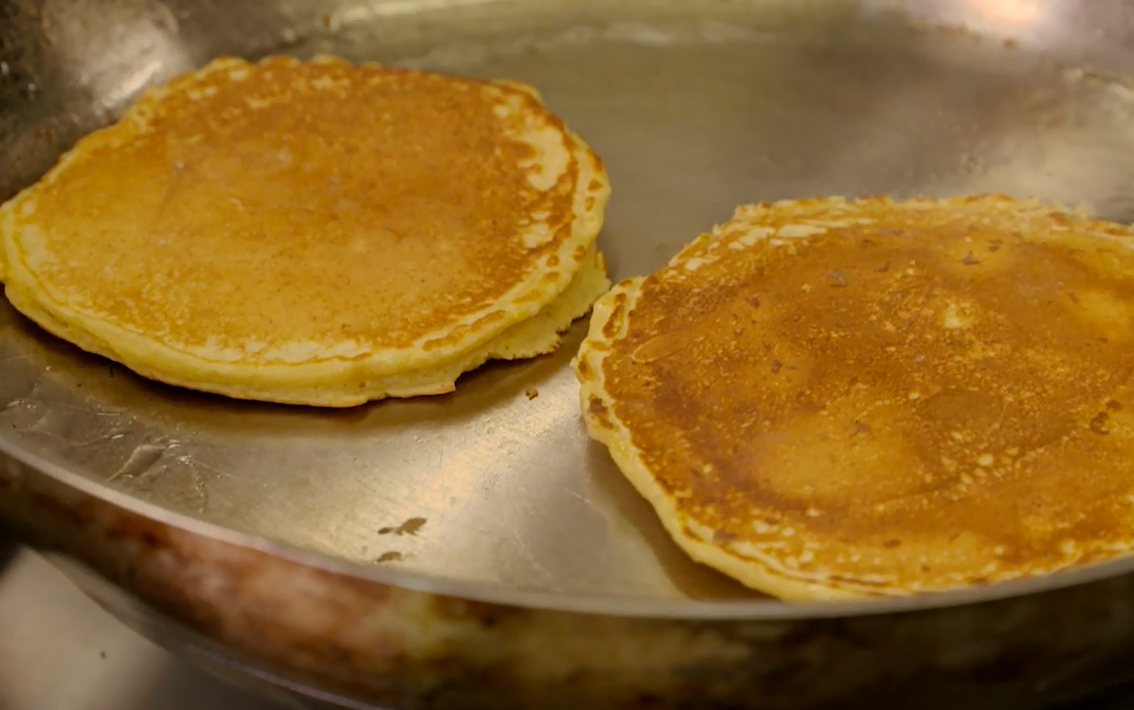

Celebrate veggies
Savoury zucchini muffins
Serves: approximately 6 large muffins or 12 regular size
Ingredients
335 g zucchini, grated
1 large onion, ½ grated, ½ diced
3 rashes of bacon, shortcut, fat trimmed, finely chopped
(Vegetarian option: replace bacon with 1 cup of mushrooms, finely diced)
1 cup tasty cheese, reduced fat, grated
1 cup wholemeal self-raising flour
1/3 cup olive oil
5 eggs
Salt and pepper to taste
25 g parmesan cheese

Method
- Pre-heat oven to 180⁰ C.
- Heat a small amount of oil in a frypan, add the grated onion and cook until soft.
- Lightly beat the eggs in a small bowl.
- In a large bowl add the grated zucchini, onion, flour, oil and beaten eggs. Season with salt and pepper.
- Combine all ingredients together in the large bowl and pour into a lightly oiled muffin tray, sprinkle lightly with parmesan cheese. Reduce the cooking time depending on the muffin size.
- Remove from pan, serve hot or cold with a side salad.
- The mixture can also be made into a slice. Increase the cooking time depending on the size of the slice pan. For a pan 16 cm x 26 cm bake for 30 to 40 minutes until cooked.
- To serve, cut the zucchini slice to the desired size and serve with a side salad.

TIP: Add additional veggies like grated carrot, spinach, turnip or parsnip for some variety.

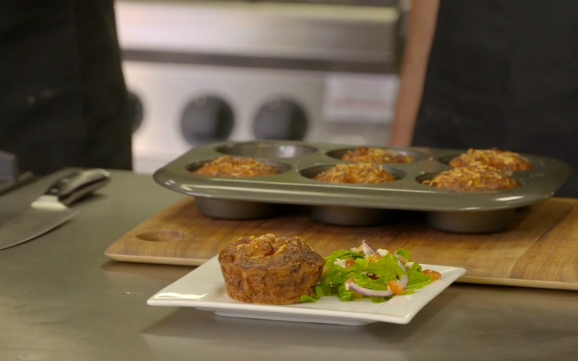
Raising funds the healthy way
Pizzas – homemade dough or pita bread base
Vegetarian pizza on a homemade dough base
Ingredients
1 cup self-raising flour
1 cup natural yoghurt
½ tsp salt
Tomato pizza sauce
Zucchini, sliced
Red onion, sliced
Semi sundried tomatoes, sliced
Capsicum, sliced
Tasty cheese, reduced fat, grated
Feta, reduced fat, crumbled
Rocket

Method
- Pre-heat oven to 180⁰ C.
- Combine the flour, yoghurt and salt in a food processor, pulse until dough-like consistency. Add more flour or yoghurt if necessary. Pulse until combined.
- Remove from the food processor and knead on a floured surface until combined.
- Roll the dough into a large pizza base with a rolling pin.
- Place on the pizza tray and top with pizza sauce and toppings.
- Bake for 15 to 20 minutes until golden brown.
- Remove from the oven and top with fresh rocket.

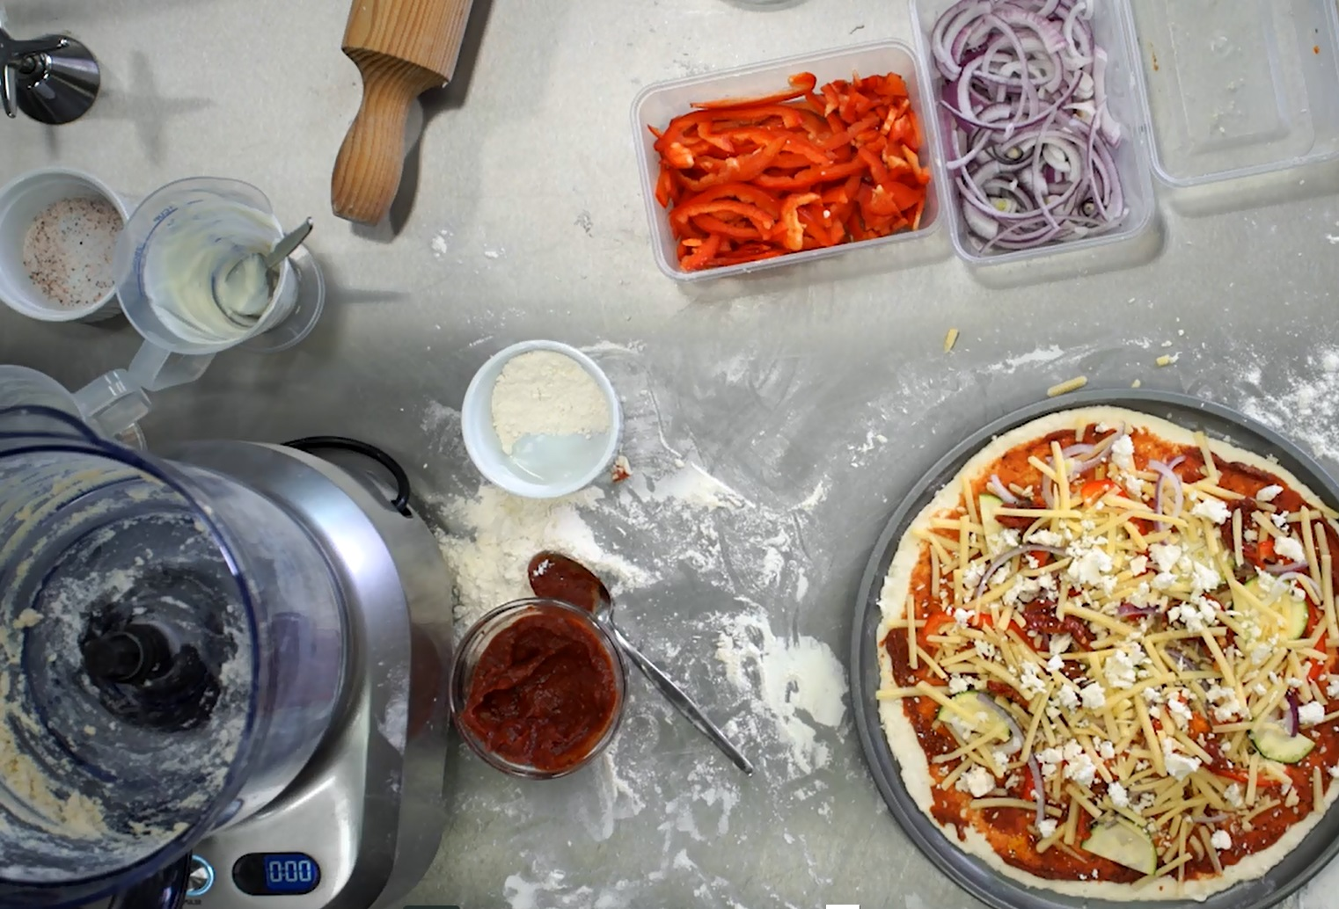

Aussie pizza on a pita bread base
Pita bread, wholemeal
Egg, lightly beaten and scrambled in a pan
Tomato pizza sauce
Ham, sliced
Pineapple, tinned, sliced
Tasty cheese, reduced fat, grated
Feta, reduced fat, crumbled

Method
- Pre-heat oven to 180⁰ C.
- Line a baking tray with greaseproof paper, place pita bread onto the tray.
- Top each pita base with pizza sauce and toppings.
- Bake for 15 to 20 minutes until golden brown.

Smoothies – dairy or fruit
Ingredients – fruit based
Watermelon, chopped
Orange, peeled and chopped, pith removed
Fresh mint leaves
Water

Ingredients – dairy based
Mixed berries, frozen or fresh
Natural yoghurt, reduced fat
Oats (optional)
Milk, reduced fat
Water

Method
- Combine ingredients (either dairy recipe or fruit based recipe) in a blender or food processor. Blend until smooth. Add water to change consistency if required. Serve chilled.

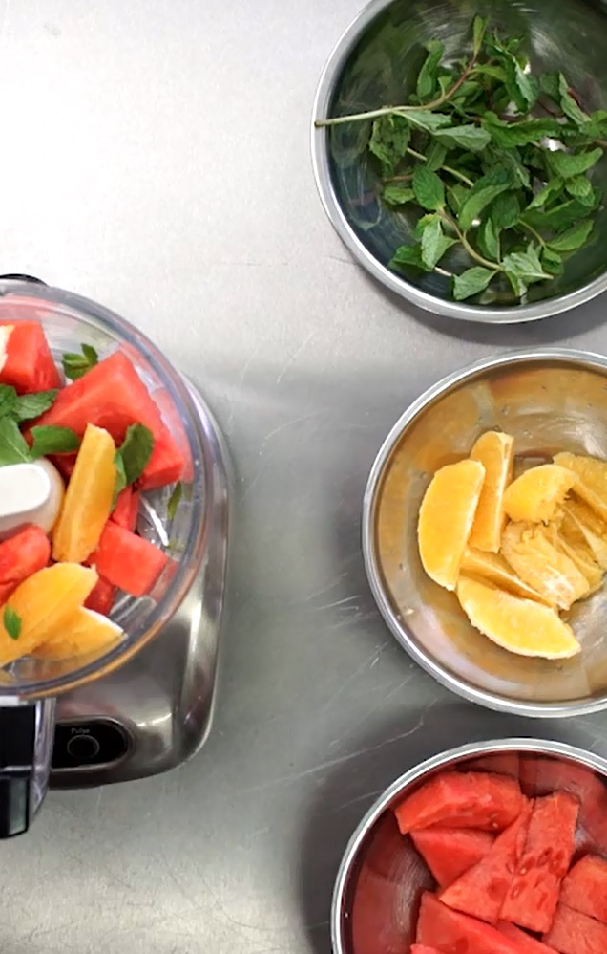

Chicken, two ways
Lemon poached chicken
Serves: approximately 6, served as a meal with salad
Ingredients
1 litre chicken stock, salt reduced
1 lemon, sliced
4 sprigs thyme
1 large chilli, sliced
1 tsp peppercorns
2 chicken breasts

Method
- Combine stock, lemon, thyme, chilli and peppercorns in a pot and bring to the boil.
- Add chicken breast and bring to the boil. Cover and remove from the heat, stand for 10 minutes.
- Remove from stock, transfer to a chopping board and slice.

Marinated chicken thighs
Serves: approximately 12 served in wraps
Ingredients
6 chicken thigh fillets
¼ cup soy sauce, salt reduced
2 cloves garlic, crushed

Method
- Trim visible fat from chicken thighs and place chicken into a ceramic dish. Pour over soy sauce and garlic. Turn to coat. Cover. Refrigerate for 30 minutes.
- Heat barbecue plate or fry pan on medium-high heat. Grill the chicken until cooked through.
- Remove from BBQ or pan, transfer to a chopping board and chop.

Tabbouleh and yoghurt dressing
Ingredients - Tabbouleh
½ cup cous cous
1 ½ cup water
2 shallots, chopped
1 medium tomato, chopped
1 cup flat leaf parsley, chopped
¼ cup mint leaves, chopped
1 tbsp lemon juice

Ingredients – Yoghurt sauce
½ cup natural yoghurt, reduced fat
1 tbs tahini
2 tbsp lemon juice
1 clove garlic, crushed

Method
- Place cous cous in a bowl, pour boiling water over the cous cous, cover, and let sit for 10 minutes.
- Add shallots, tomato, parsley, mint and lemon juice. Mix to combine and add salt to taste.
- To make the yoghurt sauce, whisk all ingredients together in a bowl and season to taste.

Serving suggestion
- As a wrap – place a spoonful of tabbouleh salad onto a wholemeal wrap, add slices of poached or BBQ chicken and a dollop of yoghurt sauce – wrap and serve.
- As a salad – place a spoonful of tabbouleh salad into a bowl, add sliced poached or BBQ chicken and a dollop or yoghurt sauce.
