
Cooking with the Sassy Chef
2015 Recipes
Winter Warmers

Moroccan sweet potato and chickpea soup
Tuckshop serves: approximately 15
Each portion contains two serves of vegetables
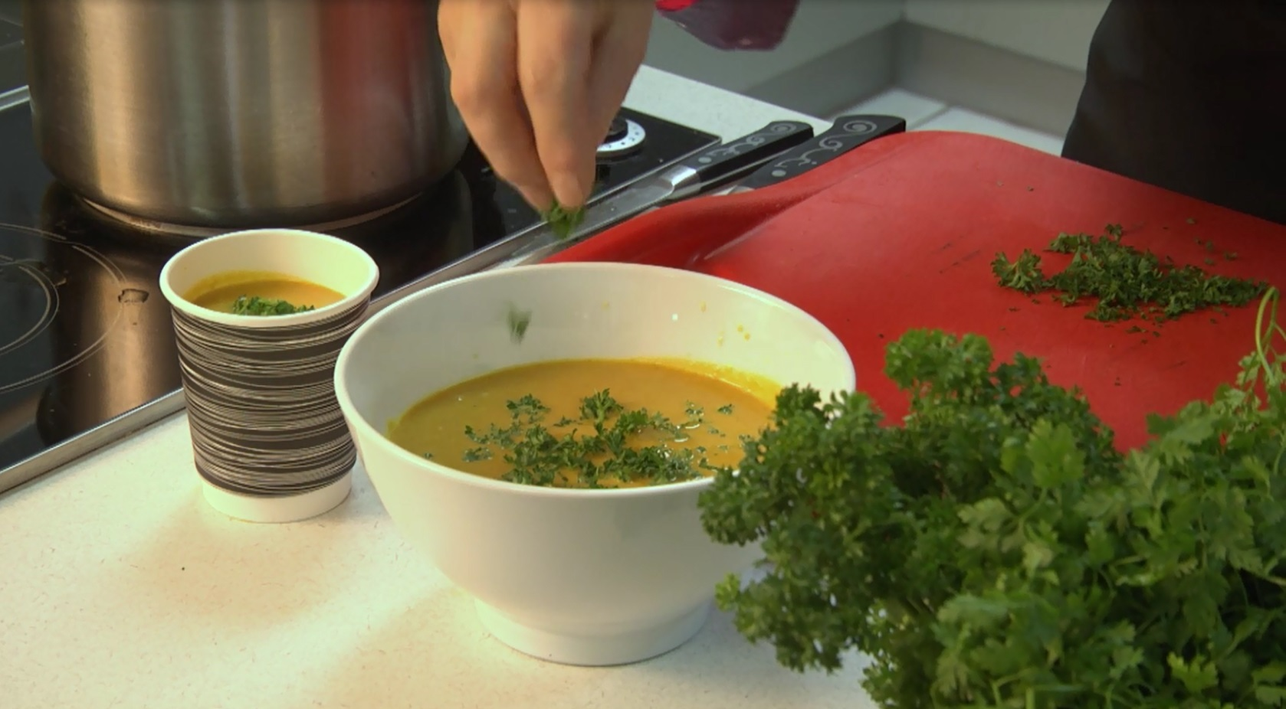
Ingredients
2 tsp olive oil
1 large onion, diced
2 stalks celery, diced
2 garlic cloves, crushed (1 tsp minced)
1 tbsp cumin
2 tsp turmeric
1 tsp cinnamon
1 kg sweet potato, peeled and diced
500 ml reduced salt chicken or vegetable stock
2 cans (800 g) chickpeas, rinsed and drained
300 ml reduced fat milk
Salt and pepper to season

Method
- Heat the oil in a large pot, add the onion and celery, cook gently until translucent.
- Add garlic and spices, cook for 2 minutes on a low heat.
- Add sweet potato and stock and bring to the boil.
- Reduce heat to a gentle simmer to soften the vegetables.
- Puree using a stick blender until reasonably smooth, stir through the chickpeas, milk and seasoning.

Apricot chicken with chickpeas and sweet potato
Tuckshop serves: approximately 10
Ingredients
2 tsp olive oil
500 g chicken breast fillets, sliced into 2 cm pieces
2 celery sticks, chopped
1 leek, thinly sliced
1 large carrot, coarsely chopped
2 garlic cloves, crushed (1 tsp minced)
2 tsp ground cumin
400 g sweet potato, peeled and diced into 2 cm pieces
1 litre reduced salt chicken stock or water
1 cup (200 g) dried whole apricots, quartered
1 can (400 g) chickpeas, rinsed and drained
2 tbsp honey
Chopped fresh continental parsley or coriander, to serve

Method
- Heat the oil in a large saucepan over high heat. Add the chicken and cook for 2 minutes or until golden. Transfer to a plate.
- Reduce heat to medium. Stir in the celery, leek and carrot for 6 to 7 minutes or until soft. Add the garlic and cumin and heat for one minute or until aromatic.
- Stir in the sweet potato, stock and dried apricots, bring to the boil then reduce heat to low. Cover and simmer for 15 minutes or until the sweet potato is tender.
- Stir in the chicken and chickpeas and simmer for 5 minutes or until the chicken is cooked through.
- Add the honey, check seasoning and sprinkle with parsley to serve.

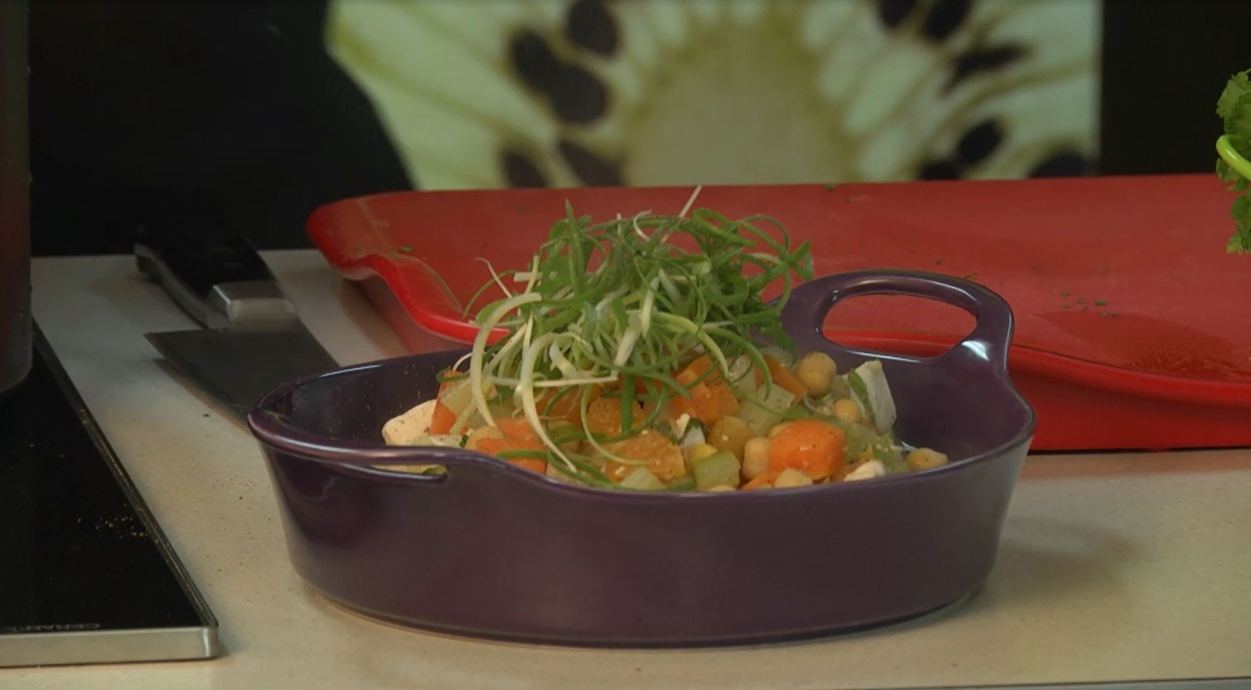

Pasta and Pesto, a perfect combination
Homemade perfect pesto
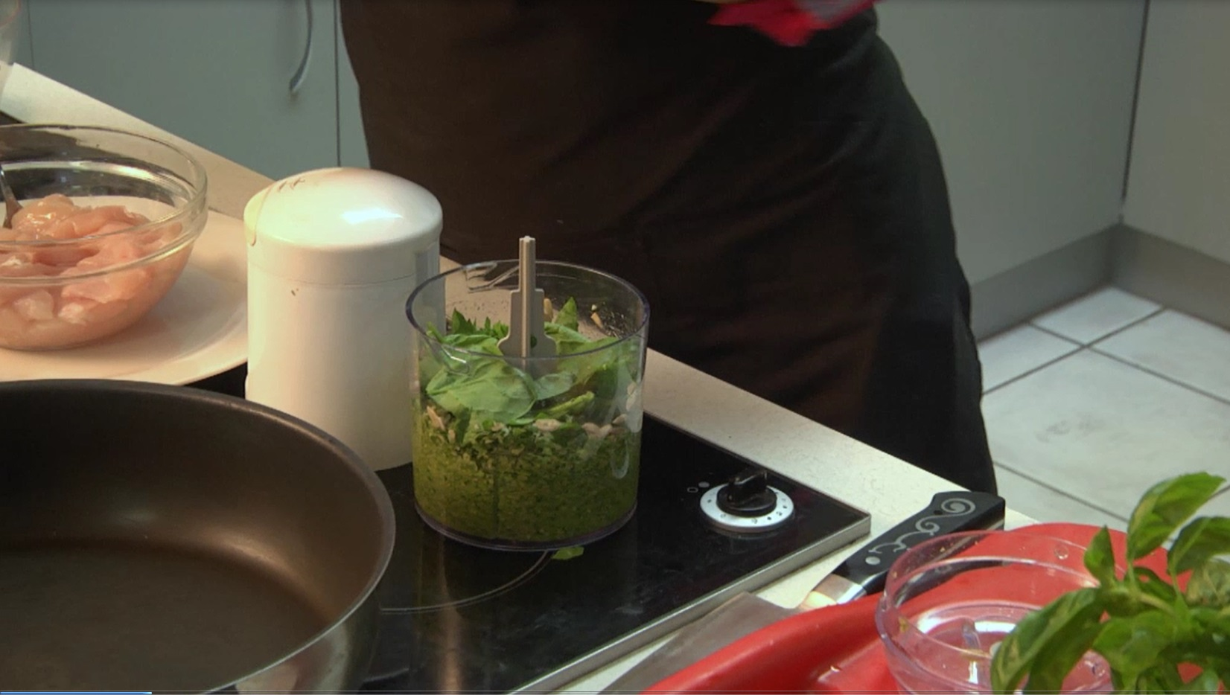
Ingredients
3 cloves garlic, coarsely chopped (1 1/2 tsp minced)
1 cup raw sunflower seeds
2 large handfuls basil leaves, coarsely chopped
1 large handful baby spinach
185 ml olive oil
50 g parmesan cheese, grated finely
Salt and cracked black pepper to season

Method
- Combine all ingredients in a food processor or a mortar and pestle and either blend or pound into a rough paste.
- Check seasoning and add more pepper, to taste.
- Keep in an airtight container for up to five days in the fridge or up to three weeks in the freezer.

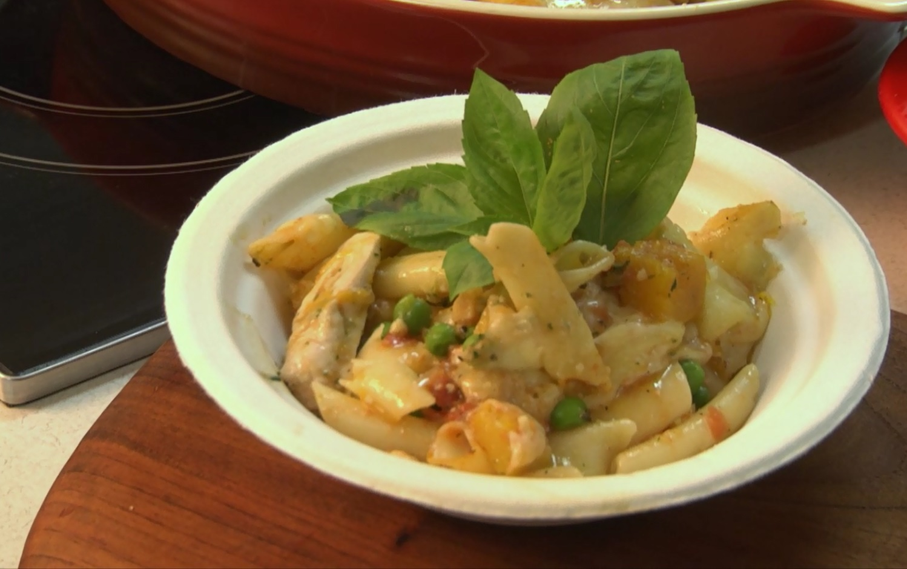
Chicken, pesto and vegetable pasta bake
Tuckshop serves: approximately 5
Ingredients
1 tbsp olive oil
500 g chicken breast, sliced finely
1 onion, finely diced
3 cloves garlic, crushed (1 1/2 minced)
2 tsp Italian dried herbs
1 can (400 g) crushed tomatoes
250 g butternut pumpkin, diced into 2cm cubes
1/2 cup (150 g) frozen peas
1 cup (70 g) broccoli florets
2 tbs fresh homemade perfect pesto
4 cups penne pasta, cooked
1/2 cup (40 g) reduced fat cheddar cheese, coarsely grated

Method
- Preheat oven to 190ºC.
- Heat the oil and cook the chicken in two batches until golden brown. Once cooked remove from the pan and set to one side.
- Add a splash more oil to the same pan, add the onions and cook gently until soft. Add the garlic and dried herbs and cook for a minute. Add the crushed tomatos and cook for 5 - 6 minutes.
- Cook the pumpkin in a pot of boiling water for 10 minutes. Add the peas and broccoli and cook for a further 1 minute or until tender.
- Combine the chicken, pasta, vegetables, pesto and tomato sauce and check the seasoning.
- Place in an ovenproof dish and sprinkle with cheese.
- Bake for 15 minutes or until heated through and the cheese is golden brown.

Chicken, pumpkin and pesto pasta
Tuckshop serves: approximately 5-6
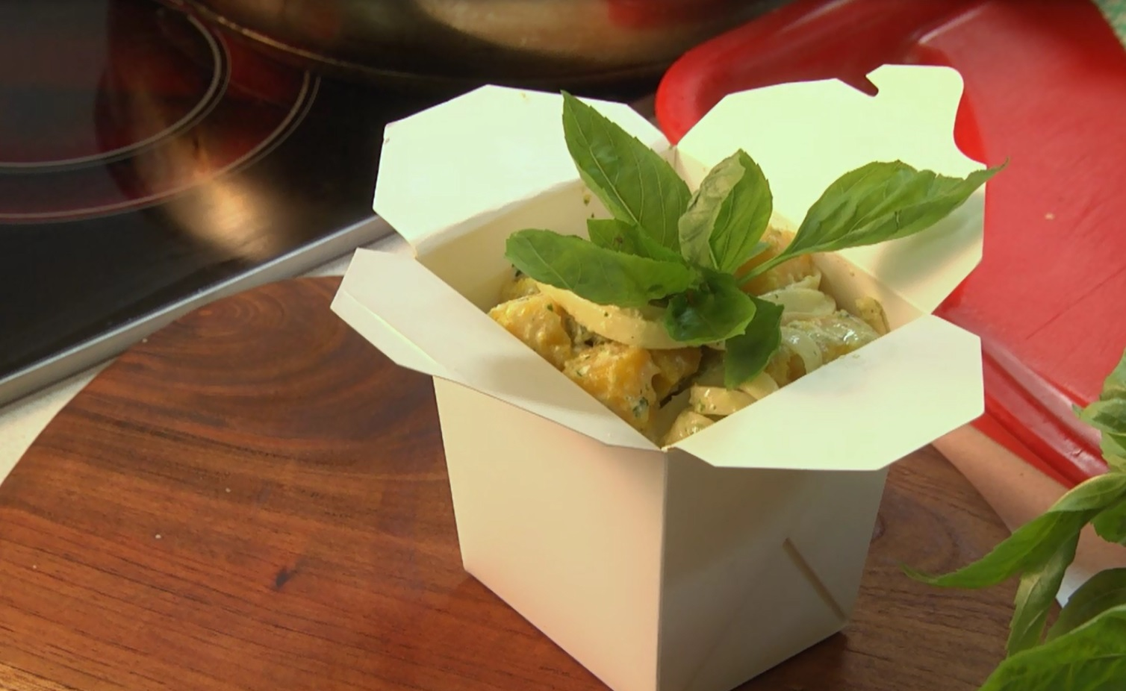
Ingredients
200g dried fettuccine
2 tbsp olive oil
2 chicken breast fillets, thinly sliced
2 tbsp pesto
1/2 cup reduced fat evaporated milk
1/2 reduced fat milk
150 g pumpkin, diced and cooked
Shaved parmesan, to serve
Basil leaves, to serve

Method
- Cook pasta according to packet directions.
- Heat the oil in a large, non-stick frying pan over medium to high heat. Add chicken and cook, stirring often for 5 minutes or until brown.
- Add the pesto, cream, milk, salt and pepper to the frying pan and reduce the heat to medium to low. Cook for 5 minutes or until sauce has thickened slightly then add the cooked pumpkin and heat for a minute.
- Drain pasta and add pesto mixture. Toss over low heat until well combined. Transfer to serving bowls and top with parmesan and basil, serve warm.

Sushi Rolls
Tuckshop serves: approximately 12

Ingredients
370 g sushi rice, uncooked
500 ml cold water
Sushi seasoning (to taste) or mirin, rice wine vinegar, sugar and salt to taste
6 nori sheets
Assorted fillings: avocado, cooked chicken or prawn, tuna fish, cucumber, red capsicum, snow pea sprouts

Method

Cooking sushi rice
- Place the rice in a sieve. Rinse under cold running water - to remove any excess starch - until water runs clear.
- Place the rice and water in a saucepan on medium heat. Bring to the boil. Reduce heat to low and cook until all the water has almost disappeared and steam funnels appear. Cover with lid, remove from heat and stand to one side for 10 minutes.
- Transfer rice to a large glass bowl. Use a fork to break up rice lumps while gradually adding the sushi seasoning, gently fold to combine. Place the rice on a plastic or wooden tray and allow to cool, fold and fan the rice until its cold.

Making the sushi rolls
- Place a sushi mat on a clean surface with slats running horizontally. Place a nori sheet, shiny-side up, on the mat. Use wet hands to spread half of the rice over the nori sheet, leaving a 3cm wide border along the edge furthest away from you.
- Place your chosen filling along the centre of the rice. Hold filling in place while rolling the mat over to enclose the rice and filling. Repeat with remaining nori, rice, and fillings.
- Wrap with plastic wrap and refrigerate for about half an hour.
- Use a sharp serrated edged knife to slice sushi width ways into 1.5 cm thick slices. Place on serving dishes with soy sauce, wasabi and pickled ginger, if desired.

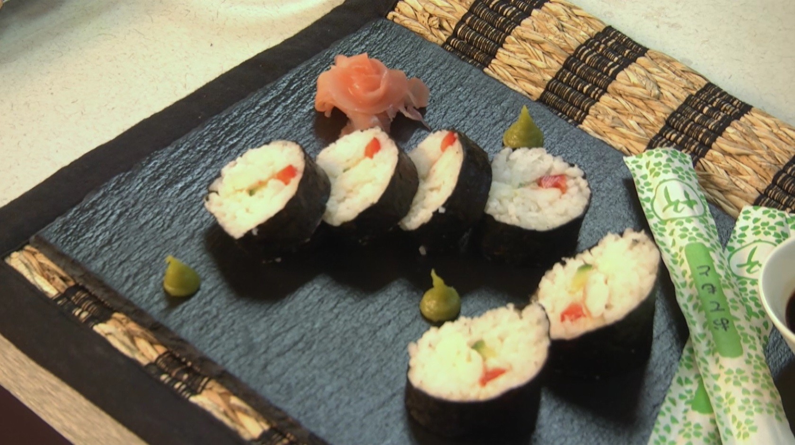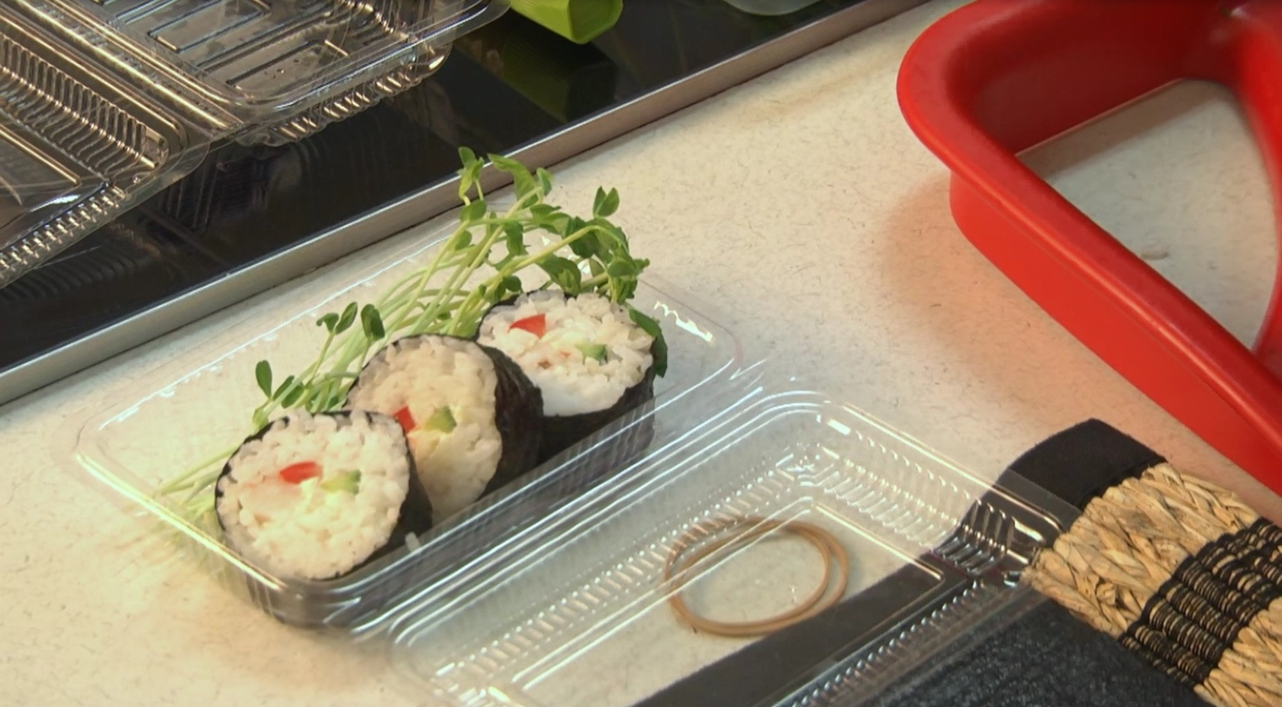

Snacks that Sell
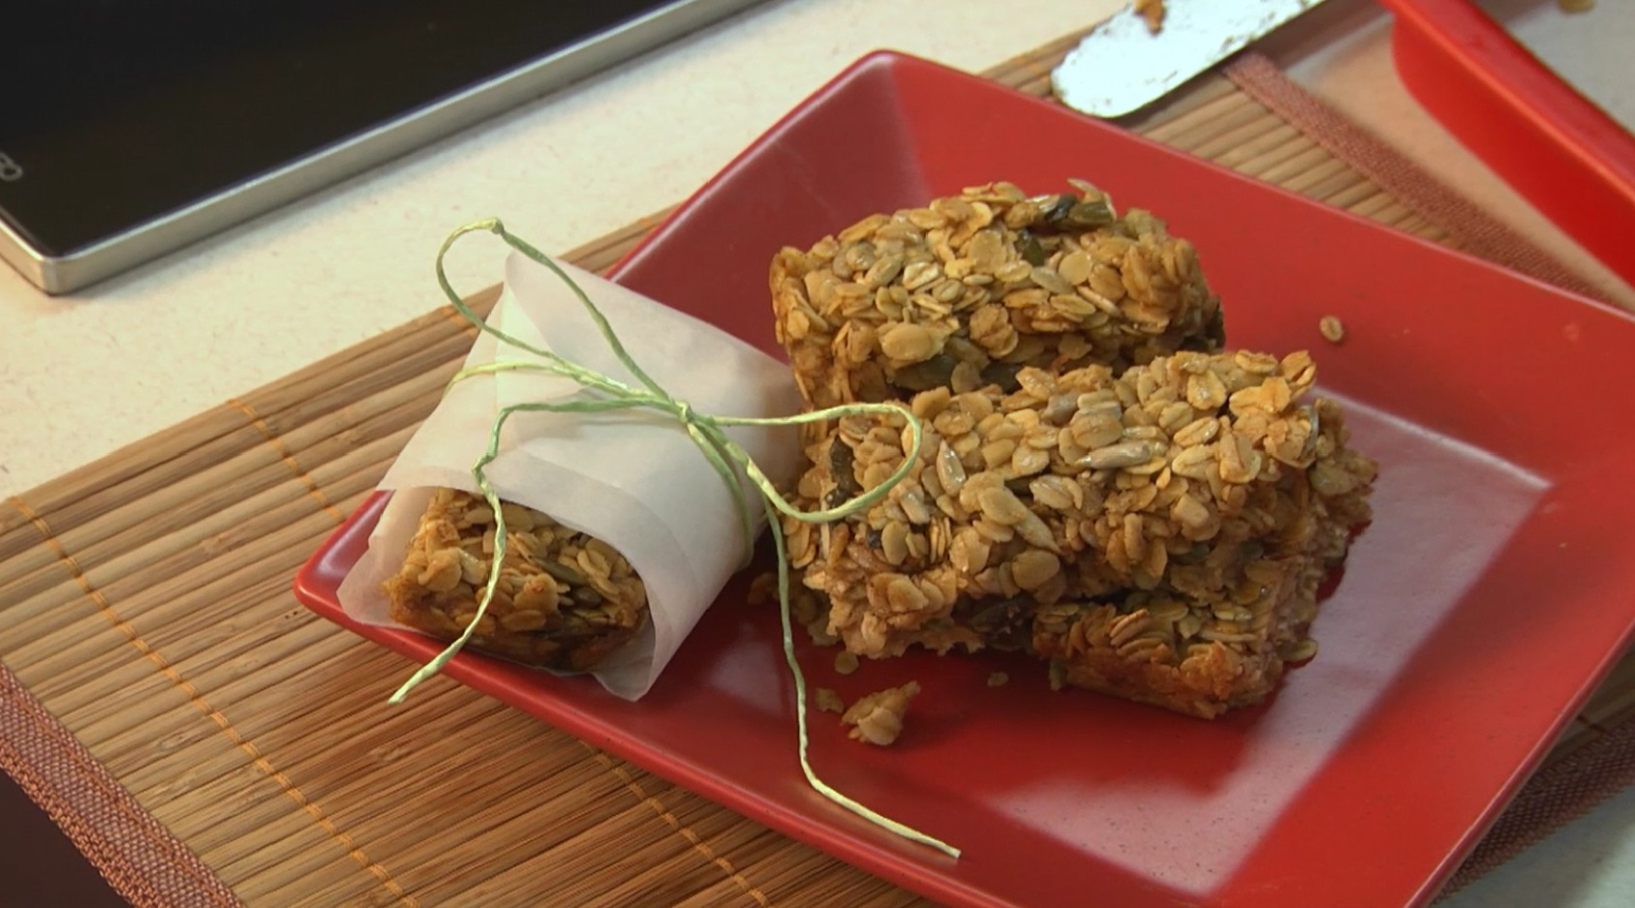
Muesli bars
Tuckshop serves: approximately 24

Ingredients
3 cups of rolled oats
1/2 cup of pumpkin and sunflower seeds
3 eggs, beaten well
1 tsp vanilla extract
1 tsp cinnamon powder
½ cup (125 ml) olive oil
¾ cup (185 ml) honey

Method
- Preheat the oven to 160 °C.
- Place oats, seeds, vanilla, cinnamon, eggs, olive oil and honey in a large bowl and mix until combined.
- Spoon mixture into a baking tin lined with baking paper and push flat to about 2 cm deep.
- Bake for 20 - 25 minutes or until golden brown.
- Cool thoroughly. Using a serrated knife cut into muesli bar sized pieces.

Apple and sultana muffins
Tuckshop serves: approximately 12
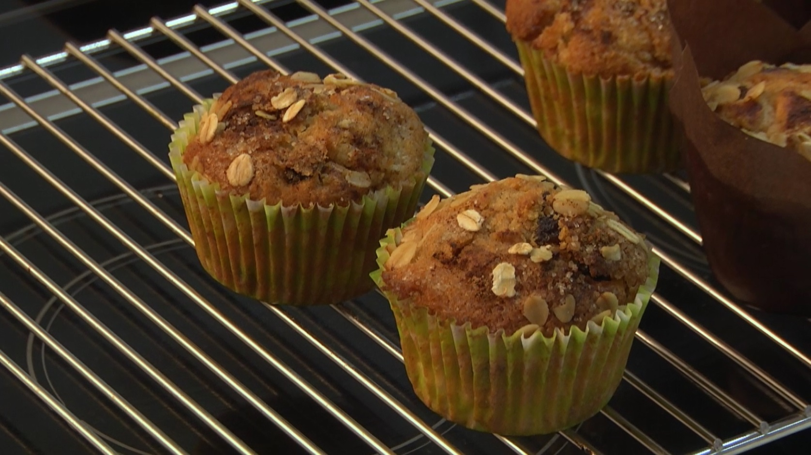
Ingredients
125 g margarine, melted and cooled
1/2 cup raw sugar
1 extra large egg, beaten well
3/4 cup reduced fat milk
1 1/2 cups self-raising flour
1 tsp cinnamon
1 1/2 cups canned apples, diced
1/2 cup sultanas
Extra oats, cinnamon and raw sugar for the tops
12 muffin papers

Method
- Preheat the oven to 190°C.
- Combine the melted margarine, sugar, egg and milk in a large bowl and mix well with a whisk.
- Gradually sieve in the flour and cinnamon and gently mix with a spoon to combine.
- Fold in the apples and sultanas.
- Spoon into muffin tins, top with a sprinkle of oats, raw sugar (if desired) and cinnamon.
- Place into the oven for 15 - 20 minutes or until the mixture springs back when touched or a skewer is inserted in the middle and it comes out clean, cool on a cooling rack.

Crudités and tzatziki
Tuckshop serves: approximately 8
Ingredients
Lebanese cucumber, sliced into sticks
Celery, sliced into sticks
Carrot, sliced into sticks
Red capsicum, sliced into sticks
Green capsicum, sliced into sticks
175 g tub reduced fat natural yoghurt
1 garlic clove, crushed (1/2 tsp minced)
1 large handful mint leaves, chopped finely
1/2 lemon, juice and grated rind
Salt and pepper to season

Method
- Mix garlic, lemon rind and juice, mint leaves and seasoning with yoghurt to make the tzatziki dip.
- Serve in a cup with dip at the bottom or in a plastic container.
- Keep refrigerated.

