2014 Queensland Tuckshop Sandwich Designer of the Year
Sandwich Recipes
State Winner – Anna Keefe – St William’s Primary School (Grovely)
- The Tunalicious
Flat bread
2 tablespoons olive oil
390 g plain flour
2 teaspoons salt
2 teaspoons yeast
275 g water

Combine dry ingredients in a mixing bowl. Slowly add water and knead until combined. Separate dough into golf ball sized pieces and roll with a rolling pin. Cook in a frying pan for one minute on each side.

Filling
Tuna, canned, in spring water
Mayonnaise, reduced fat
Sweet chilli sauce
Lettuce
Red onion
Carrot, grated
Alf alfa
Crunchy sprouts
Herbs (dill, flat leaf parsley and chives), chopped

To assemble
1. Prepare flat bread, or alternatively use ready-made wraps, rolls or bread.
2. Drain tuna and mix with mayonnaise and sweet chilli sauce.
3. Place all filling ingredients inside the flat bread and roll.
4. Wrap in paper and serve.

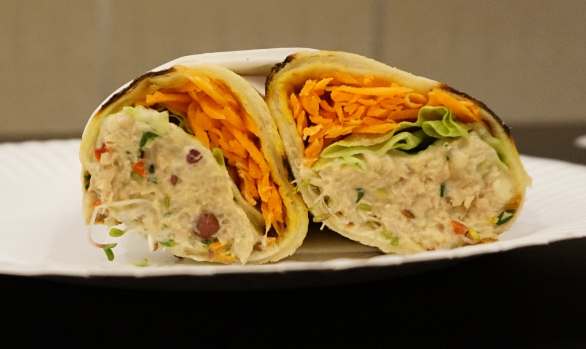
State Finalists
Suzy McKenzie – Yarwun State School
- Sunny Chicken Divine Sandwich
Ingredients
Multigrain bread, baked fresh on site
Eggs, boiled and peeled
Lettuce
Cherry tomatoes
Parsley
Cucumber
Shallots
Mayonnaise, homemade
Method
1. Combine a small amount of mayonnaise with mashed egg, spread lightly onto the bread.
2. Assemble all ingredients as displayed below.
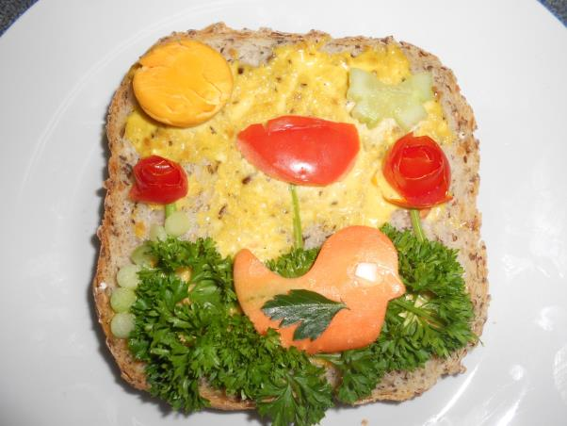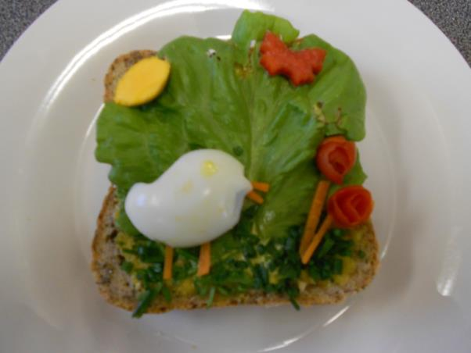
Natalie Brugh – Malanda State High School
- Chicken and Wombok Salad Wrap
Ingredients
Tortilla
Crunchy noodles
Grilled, chicken
Slithered almonds, toasted
Wombock cabbage, shredded
Shallots
Carrot, grated
Honey and soy mayonnaise, homemade
Method
1. Layer all ingredients onto the tortilla wrap.
2. Wrap in paper and serve.

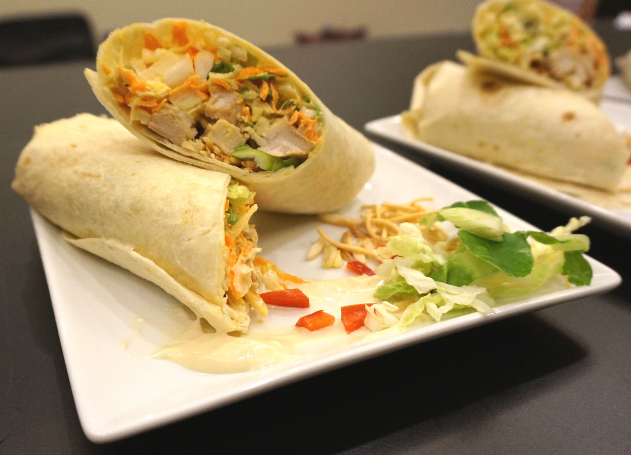
Gayle Cooper – Kawana Waters State College
- Chicken Delight
Ingredients
Wholemeal chia bread
Chicken breast, sliced
Swiss cheese, slice
Baby spinach
Carrot, grated
Red onion, sliced
Avocado, sliced
Aioli
Cranberry jelly
Pomegranate
Method
1. Layer all ingredients onto the bread; ensure moist ingredients are placed into the middle of the sandwich.
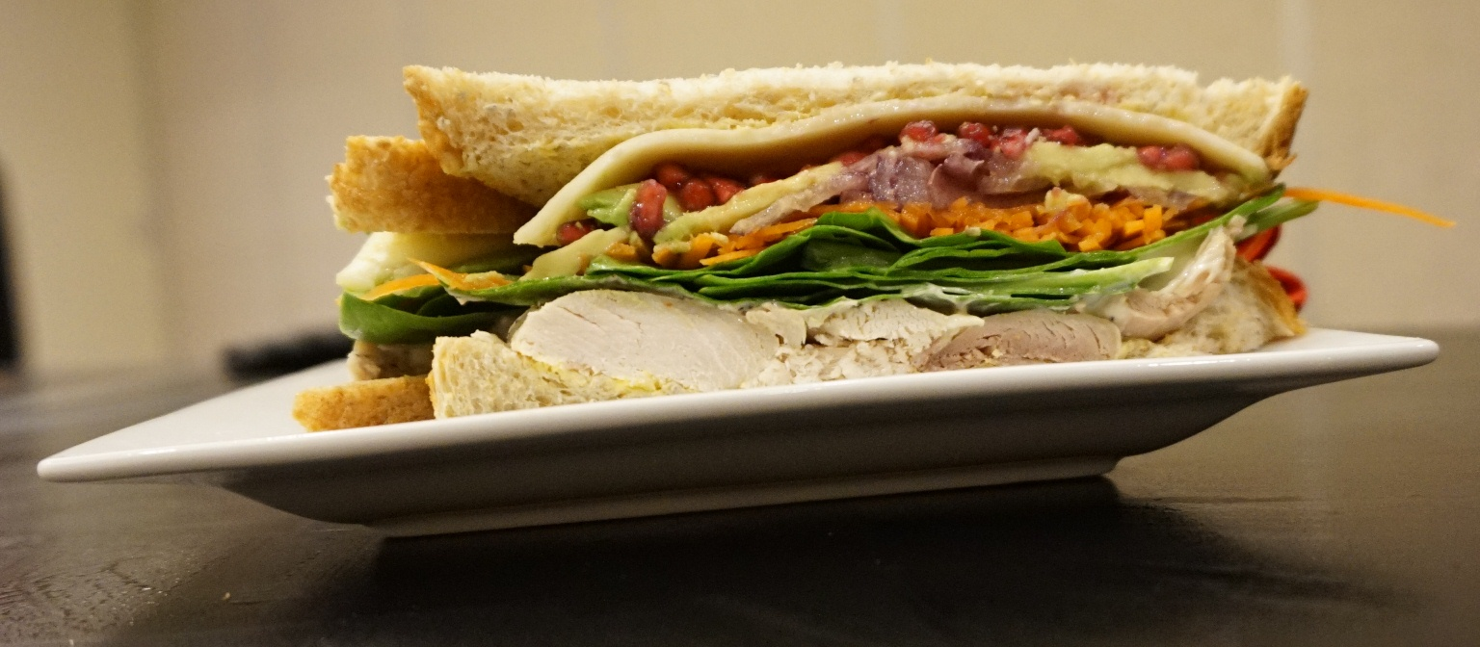
Kylie Gilling and Michelle Blackwood – Centenary State School
- Chicken Harvest Delite Sandwich
Ingredients
Grainy bread
Roast chicken breast
Baby spinach
Tomato
Celery, diced
Spanish onion, diced
Ricotta cheese, reduced fat
Dried apricot, diced
Tarragon
Dijon mustard
Lemon juice
Method
1. Combine celery, Spanish onion, ricotta cheese, dried apricot, tarragon, Dijon mustard and lemon juice.
2. Layer chicken, salad vegetables and ricotta cheese mix onto the bread.
3. Place into a sandwich box and serve.
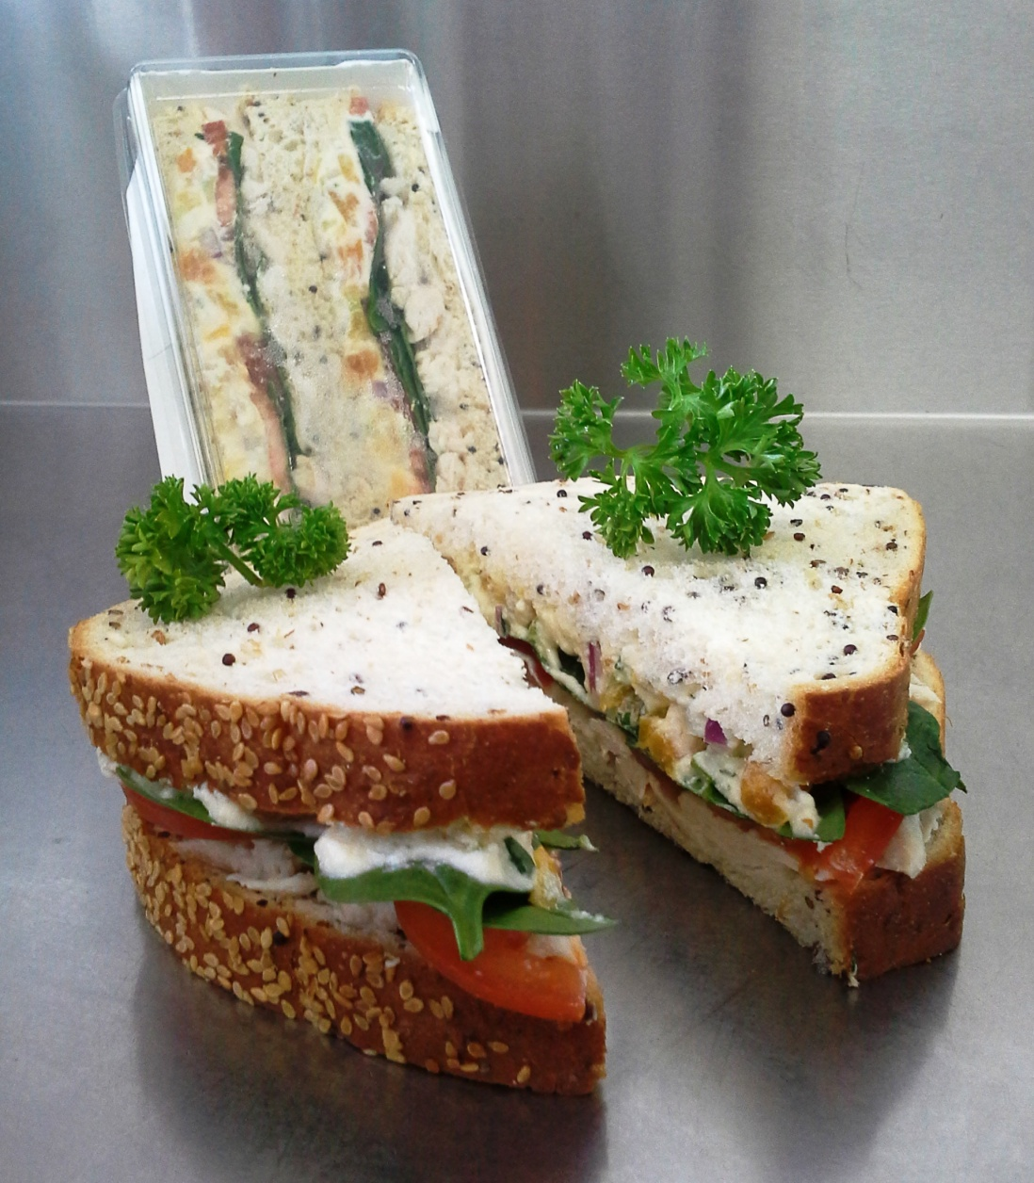
Jenny Munro – Coombabah State School
- Mexican Beef Wrap
Ingredients
1/2 cup pulled roast beef
1/2 cup rice, cooked and cooled
1/4 cup corn
2 tablespoons salsa
1 tablespoon coriander leaves, chopped
Lime juice, fresh
Avocado
Lettuce, shredded
Carrot, grated
Cucumber, sliced
Baby spinach
Aioli dressing, homemade
Tortilla wrap
Method
1. Mix the pulled beef, corn, salsa, rice, coriander and lime juice together.
2. Lightly spread the wrap wit aioli dressing.
3. Layer salad and beef mixture, slice into bite sized rolls and enjoy.
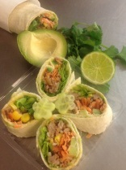
Sharyn Moore – Kimberley College
- Beef Bonanza
Ingredients
Long roll, seeded square or Turkish bread roll
Shredded beef, slow cooked on site
Lettuce, shredded
Cucumber, sliced
Carrot, grated
Tomato, sliced
Tomato relist, homemade
Method
1. Slow cook beef, whilst warm pull apart with a fork. Place into the fridge to cool.
2. Layer ingredients onto your choice of bread.
3. Serve and enjoy.
